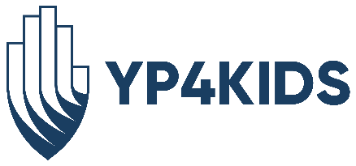

YP4Kids 2022-2023 School Year

Purpose
To establish a collective group of young professional adults to increase awareness of The Oklahoma City Public Schools Foundation and support the mission of the organization through fundraising and service. These professionals under the age of 40 will foster lasting supporting and service of The OKCPS Foundation by engaging directly through donated time, talent and treasure.

Goals
- Fundraising: Annual Golf Tournament and T-Up for OKCPS
- Have every YP4Kids member attend and/or volunteer at least once at a foundation event per school year
- Collectively complete at least two Partners In Action projects annually
- Increase engagement and awareness of The Foundation’s Coat-a-Kid initiative, and contribute a portion of fundraising dollars to this program if funds are available
- Participate in at least one volunteer opportunity with ReadOKC
  - On the Go! Book Bus
  - Reading Buddy
  - Little Library Steward
- Continue to grow the YP4Kids group and have at least 25 active members each year
Responsibilities
- Serve as an active advocate of The OKCPS Foundation
- Make a personal contribution as a Friend of the Foundation
- Contribute to one Donors Choose project annually
- Assist in fundraising activities
- Attend at least (2) board meetings or events
- Provide volunteer support as needed
Structure
- 25-35 members
- Target age range 40 and under
- 12-month term
- Meetings will be held quarterly
- The Chair & Chair-Elect will serve on the Advisory Board of The OKCPS Foundation, which meets twice per year with the full Board of Directors.

